**HAMZA EJAZ**

**S # B19102041**

**BSCS-III (MORNING)**

**Section-A**

**Database Management**

**System**

**1) Write a PL/SQL program to generate Fibonacci series for numbers from 1 -15**

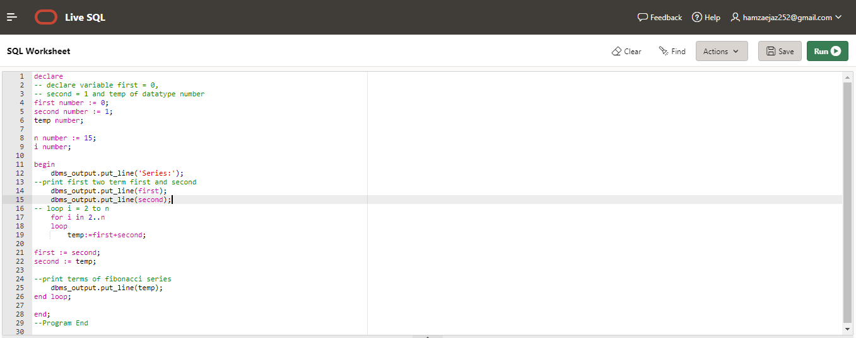

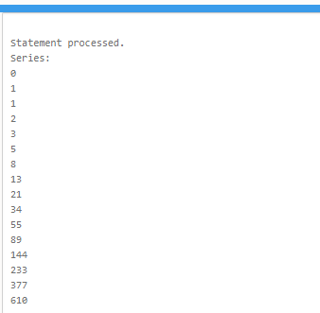

**2) Write a PL/SQL program to check if the given string is Palindrome or not**

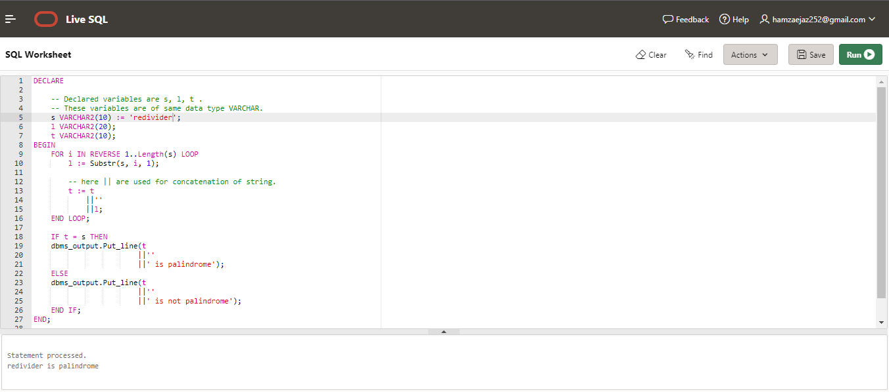

**3) Write a PL/SQL program to accept two numbers A and B and print their sum**

